Connect the control card to computer via RS232 or RS485

Open the setting software

Step1

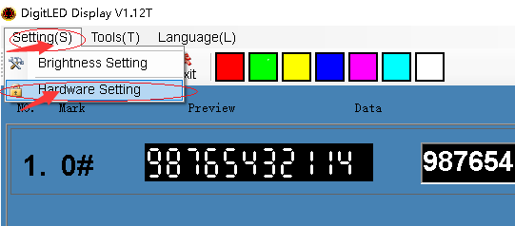

Step2, input password: LED888

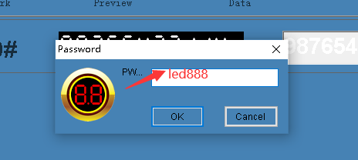

Step3 setting group and words

